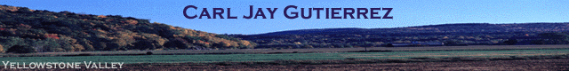

Stapleton Homeowners

Payment

From: | Carl Jay Gutierrez, MD | Phone: (406) 545-8842
____________________________________________________________________________________________

Please apply the enclosed funds to my balance.

Unit 406

# | Invoice →
□ | Paid—Check

Address:

4180 Harbor Rd | 3600 Ave du Parc A-2809 | 104 N. Broadway (28th St) #406
Shelburne, VT 05482-6005 | Montreal, QC H2X3R2 | Billings, MT 59101-2074
USA | Canada | USA
http://mapq.st/HarborRdShelburne | http://mapq.st/MontrealLaCite | http://mapq.st/BillingsCondo

130 Schmittle Rd | 9035 Crossbox Ln | 110 Schmittle Rd
Lemitar, NM 87823 | Billings, MT 59106-4612 | Lemitar, NM 87823
www.bit.ly/NMFarm | http://mapq.st/MontanaCabin | www.bit.ly/NMMercer

Thank You.

Carl Jay Gutierrez, MD

HPM, LLC
PO Box 21172
Billings, MT 59104

cjgonline@hotmail.com www.carljay.com

